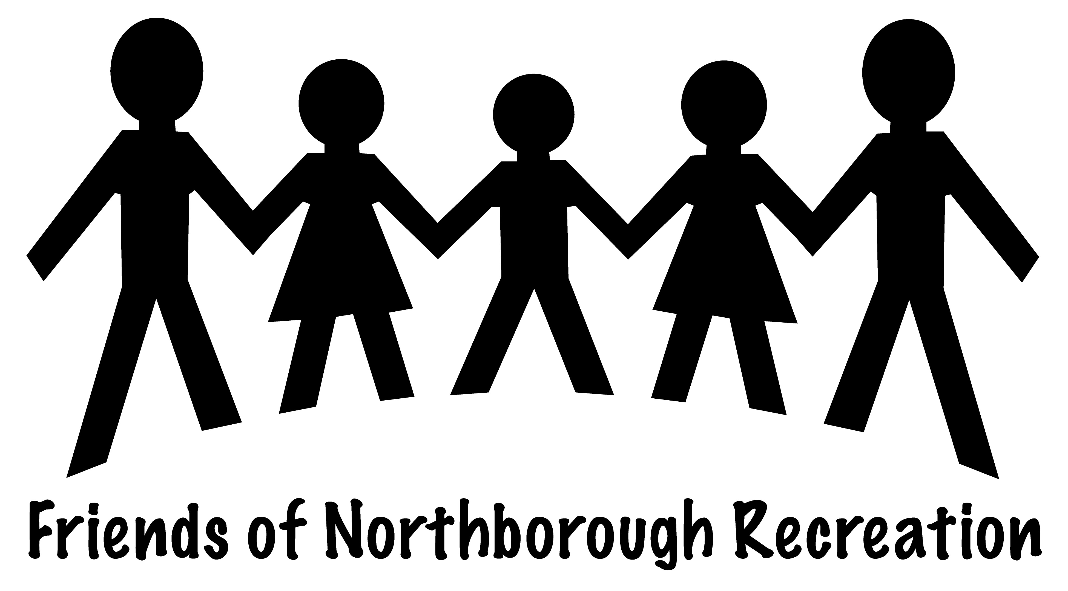
Our mission is to raise the needed funds to send Northborough children (K-8) of families suffering financial hardship to Northborough Recreation's summer camp. This past summer (2010), the Northborough Recreation Department had to turn away 20 families hoping to send their kids to camp. The Recreation Department does not run on town monies and is legally unable to accept direct donations to aid in this effort. The Friends of Northborough Recreation Committee would like to help ease this financial burden for these families of our community.
HOW CAN YOU HELP? Become a member of the Friends of Northborough Recreation! 100% of your donation goes to towards this cause. We have two levels of membership...
Best Friend: ($100) For a donation of $100 you will receive all the benefits of being a "Friend", PLUS... THE ABILITY TO REGISTER FOR RECREATION CLASSES, CAMPS AND EVENTS ONE DAY EARLIER THAN EVERYONE ELSE!

Friend: ($25) For a donation of $25 you will receive a "I'm A Friend" T-shirt(s) for your child(ren), a 1-year membership to the Friends of Northborough Recreation including updates on the committee's efforts, our sincere thanks, and the knowledge that you have helped send a child to summer camp.

-------------------------------------------------------------------------------------------------------------- YES! I would like to help by becoming a member of the Friends of Northborough Recreation. (Cash or check only please. Checks can be made payable to the Friends of Northborough Recreation.) Forms can be mailed to Northborough Recreation, Att: Friends of Northborough Recreation, 63 Main St., Northborough
Please check one: Friend ($25) _____ Best Friend ($100) _____ Donation without membership (amount) ____ -please print clearly- Name: __________________________ Email address: __________________________
Phone: ______ ____________________ Mailing Address: _________________________
Date: ________ # of children: _____ Shirt size(s): _____ _____ _____ **boy (b) or girl (g)
THANK YOU SO VERY MUCH! YOUR KINDNESS IS SURE TO PUT A SMILE ON A CHILD'S FACE! Questions? Please feel free to contact the Friends of Northborough Recreation Committee at: friendsofnorthboroughrec@gmail.com, follow our link on Northborough Recreation’s homepage at www.northboroughrecreation.com or call Stefanie Youssef at 508-393-5034.

